Flamerobin as a GUI for embedded Firebird

Source: <http://pabloj.blogspot.ch/2006/08/flamerobin-as-gui-for-embedded.html>

In order to have [Flamerobin](http://www.flamerobin.org/) connect to an embedded Firebird database through local protocol, you need to configure Flamerobin as follows:

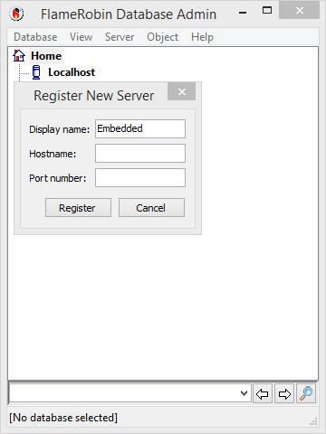  
**1**. Pick fbembed.dll from [Firebird-1.5.3.4870-0_embed_win32.zip](http://prdownloads.sourceforge.net/firebird/Firebird-1.5.3.4870-0_embed_win32.zip)  
**2**. Copy it to C:\Program Files\FlameRobin (the Flamerobin installation folder, whatever it's named  
**3**. Rename it to fbclient.dll  
**4**. **Register a new server** in Flamerobin, **without specifying the hostname and port** (leave them blank)

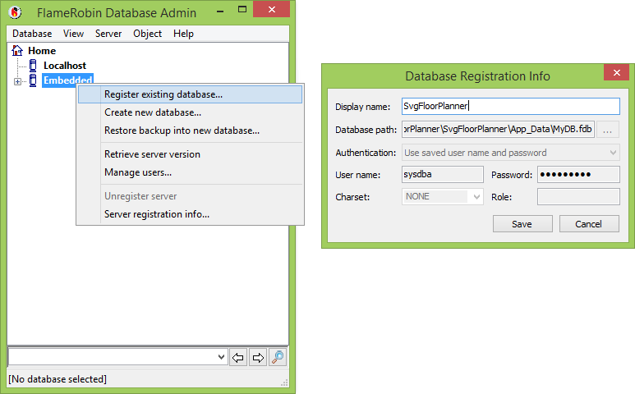**5**. Register a new database **under that server**, if you correctly left the hostname blank it will try to connect to something like "sysdba@c:\program files\employee.fdb"

**5.1**. Specify a password, because Flamerobin seems to want it, but remember that it will not be checked in the embedded version (privileges still exist!!)

**6**. You might need to copy more files from the embedded distribution to the flamerobin folder, like firebird.msg for messages, firebird.conf, ib_util.dll and the whole "intl" folder for connections with specific charsets!

Note that this allows me to keep also Firebird 2.0 RC3 installed, network connection to firebird 2 databases (new **O**n**D**isk**S**tructure) will work, while it will fail if you try to connect as embedded (local protocol)